# Hands on 1: Create a Spring Web Project using Maven

Program Structure

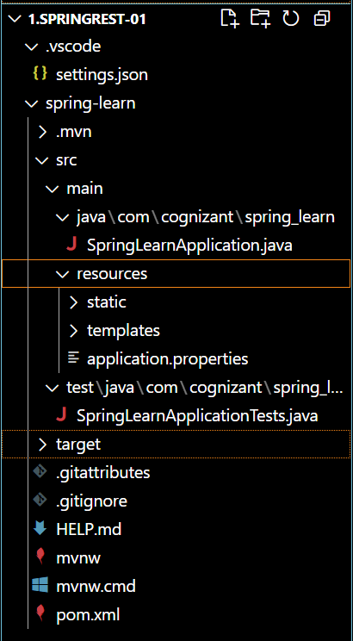

SpringlearnApplication.java

package com.cognizant.spring_learn;

import org.springframework.boot.SpringApplication;

import org.springframework.boot.autoconfigure.SpringBootApplication;

@SpringBootApplication

public class SpringLearnApplication {

    public static void main(String[] args) {

        SpringApplication.run(SpringLearnApplication.class, args);

    }

}

SpringLearnApplicationTests.java

package com.cognizant.spring_learn;

import org.junit.jupiter.api.Test;

import org.springframework.boot.test.context.SpringBootTest;

@SpringBootTest

class SpringLearnApplicationTests {

    @Test

    void contextLoads() {

    }

}

pom.xml

<?xml version="1.0" encoding="UTF-8"?>

<project xmlns="http://maven.apache.org/POM/4.0.0" xmlns:xsi="http://www.w3.org/2001/XMLSchema-instance"

    xsi:schemaLocation="http://maven.apache.org/POM/4.0.0 https://maven.apache.org/xsd/maven-4.0.0.xsd">

    <modelVersion>4.0.0</modelVersion>

    <parent>

        <groupId>org.springframework.boot</groupId>

        <artifactId>spring-boot-starter-parent</artifactId>

        <version>3.5.3</version>

        <relativePath/> <!-- lookup parent from repository -->

    </parent>

    <groupId>com.cognizant</groupId>

    <artifactId>spring-learn</artifactId>

    <version>0.0.1-SNAPSHOT</version>

    <name>spring-learn</name>

    <description>Demo project for Spring Boot</description>

    <url/>

    <licenses>

        <license/>

    </licenses>

    <developers>

        <developer/>

    </developers>

    <scm>

        <connection/>

        <developerConnection/>

        <tag/>

        <url/>

    </scm>

    <properties>

        <java.version>17</java.version>

    </properties>

    <dependencies>

        <dependency>

            <groupId>org.springframework.boot</groupId>

            <artifactId>spring-boot-starter-web</artifactId>

        </dependency>

        <dependency>

            <groupId>org.springframework.boot</groupId>

            <artifactId>spring-boot-devtools</artifactId>

            <scope>runtime</scope>

            <optional>true</optional>

        </dependency>

        <dependency>

            <groupId>org.springframework.boot</groupId>

            <artifactId>spring-boot-starter-test</artifactId>

            <scope>test</scope>

        </dependency>

    </dependencies>

    <build>

        <plugins>

            <plugin>

                <groupId>org.springframework.boot</groupId>

                <artifactId>spring-boot-maven-plugin</artifactId>

            </plugin>

        </plugins>

    </build>

</project>

Output:

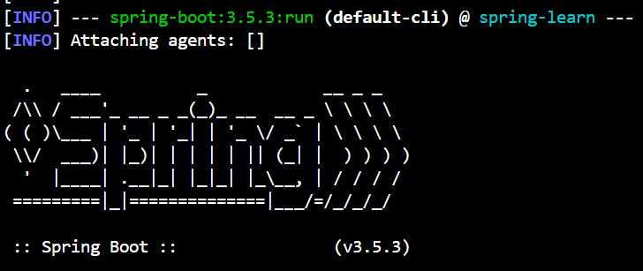

# Hands on 4: Spring Core – Load Country from Spring Configuration XML

Program structure

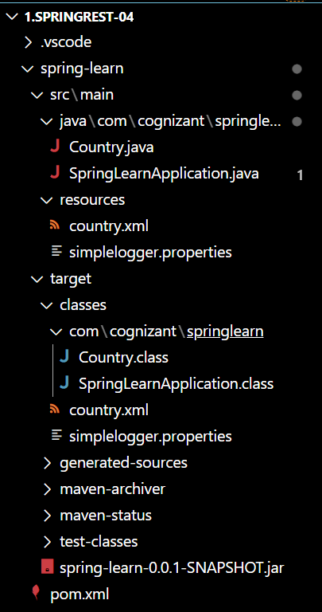

Country.java

package com.cognizant.springlearn;

import org.slf4j.Logger;

import org.slf4j.LoggerFactory;

public class Country {

    private String code;

    private String name;

    private static final Logger LOGGER = LoggerFactory.getLogger(Country.class);

    public Country() {

        LOGGER.debug("Inside Country Constructor.");

    }

    public String getCode() {

        LOGGER.debug("Inside getCode()");

        return code;

    }

    public void setCode(String code) {

        LOGGER.debug("Inside setCode()");

        this.code = code;

    }

    public String getName() {

        LOGGER.debug("Inside getName()");

        return name;

    }

    public void setName(String name) {

        LOGGER.debug("Inside setName()");

        this.name = name;

    }

    @Override

    public String toString() {

        return "Country [code=" + code + ", name=" + name + "]";

    }

}

SpringlearnApplication.java

package com.cognizant.springlearn;

import org.slf4j.Logger;

import org.slf4j.LoggerFactory;

import org.springframework.context.ApplicationContext;

import org.springframework.context.support.ClassPathXmlApplicationContext;

public class SpringLearnApplication {

    private static final Logger LOGGER = LoggerFactory.getLogger(SpringLearnApplication.class);

    public static void main(String[] args) {

        displayCountry();

    }

    public static void displayCountry() {

        ApplicationContext context = new ClassPathXmlApplicationContext("country.xml");

        Country country = context.getBean("country", Country.class);

        LOGGER.debug("Country : {}", country.toString());

    }

}

country.xml

<?xml version="1.0" encoding="UTF-8"?>

<beans xmlns="http://www.springframework.org/schema/beans"

       xmlns:xsi="http://www.w3.org/2001/XMLSchema-instance"

       xsi:schemaLocation="http://www.springframework.org/schema/beans

       http://www.springframework.org/schema/beans/spring-beans.xsd">

    <bean id="country" class="com.cognizant.springlearn.Country">

        <property name="code" value="IN" />

        <property name="name" value="India" />

    </bean>

</beans>

pom.xml

<project xmlns="http://maven.apache.org/POM/4.0.0"

         xmlns:xsi="http://www.w3.org/2001/XMLSchema-instance"

         xsi:schemaLocation="http://maven.apache.org/POM/4.0.0

         http://maven.apache.org/xsd/maven-4.0.0.xsd">

    <modelVersion>4.0.0</modelVersion>

    <groupId>com.cognizant</groupId>

    <artifactId>spring-learn</artifactId>

    <version>0.0.1-SNAPSHOT</version>

    <properties>

        <java.version>17</java.version>

    </properties>

    <dependencies>

        <dependency>

            <groupId>org.springframework</groupId>

            <artifactId>spring-context</artifactId>

            <version>5.3.34</version>

        </dependency>

        <dependency>

            <groupId>org.slf4j</groupId>

            <artifactId>slf4j-api</artifactId>

            <version>2.0.13</version>

        </dependency>

        <dependency>

            <groupId>org.slf4j</groupId>

            <artifactId>slf4j-simple</artifactId>

            <version>2.0.13</version>

        </dependency>

    </dependencies>

    <build>

        <plugins>

            <plugin>

                <groupId>org.apache.maven.plugins</groupId>

                <artifactId>maven-compiler-plugin</artifactId>

                <version>3.11.0</version>

                <configuration>

                    <source>${java.version}</source>

                    <target>${java.version}</target>

                </configuration>

            </plugin>

            <plugin>

                <groupId>org.codehaus.mojo</groupId>

                <artifactId>exec-maven-plugin</artifactId>

                <version>3.1.0</version>

                <configuration>

                    <mainClass>com.cognizant.springlearn.SpringLearnApplication</mainClass>

                </configuration>

            </plugin>

        </plugins>

    </build>

</project>

Output:

